GLRLMS { only 45degrees } (11/11) + GLCM (20/20) + Hu (7/7)

1. no variables excluded; no PCA; classes 1&2 and 3&4 lumped

Best classifier: KNN (k=1)

Accuracy = **87%**

AUC = 0.87

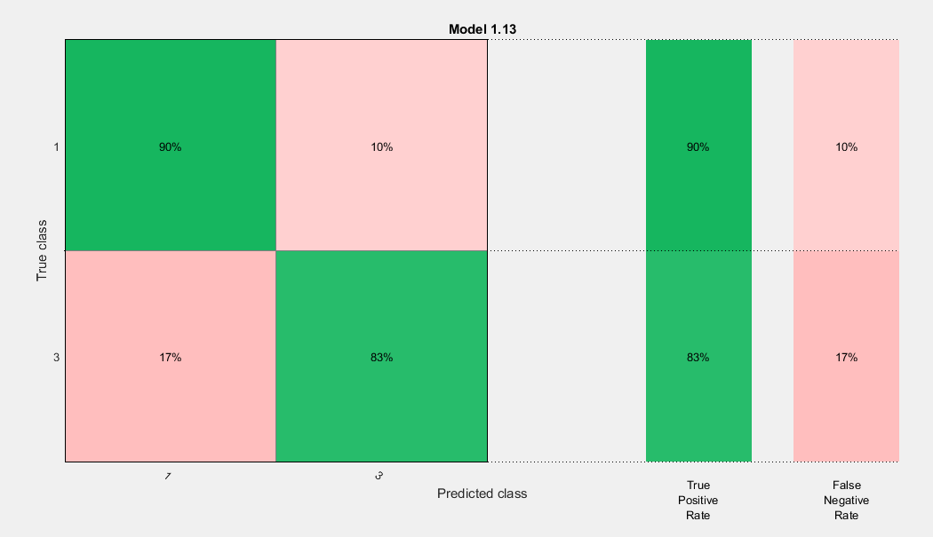

1. no variables excluded; no PCA; classes 1&2 and 3&4 lumped

Best classifier: KNN (k=1)

Accuracy = **89.6%**

AUC = 0.89

1. no variables excluded; no PCA; classes 1&2 and 3&4 lumped

Best classifier: KNN (k=1)

Accuracy = **85.7%**

AUC = 0.85

1. no variables excluded; no PCA; classes 1&2 and 3&4 lumped

Best classifier: KNN (k=1)

Accuracy = **90.9%**

AUC = 0.91

1. no variables excluded; no PCA; classes 1&2 and 3&4 lumped

Best classifier: KNN (k=1)

Accuracy = **90.9%**

AUC = 0.91

**Average accuracy = 88.82%**

GLRLMS (8/11) + GLCM (14/20) + Hu (7/7)

1. 9 variables excluded; no PCA; classes 1&2 and 3&4 lumped

Best classifier: KNN (k=1)

Accuracy = **85.7%**

AUC = 0.85

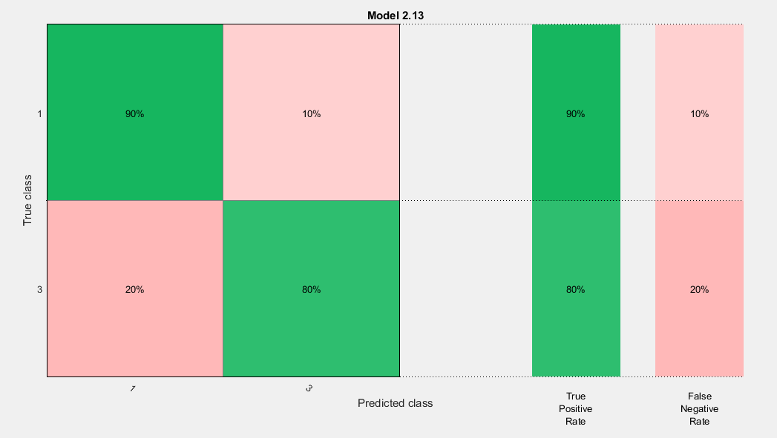

1. 9 variables excluded; no PCA; classes 1&2 and 3&4 lumped

Best classifier: KNN (k=1)

Accuracy = **89.6%**

AUC = 0.89

1. 9 variables excluded; no PCA; classes 1&2 and 3&4 lumped

Best classifier: KNN (k=1)

Accuracy = **85.7%**

AUC = 0.85

1. 9 variables excluded; no PCA; classes 1&2 and 3&4 lumped

Best classifier: KNN (k=1)

Accuracy = **88.3%**

AUC = 0.88

1. 9 variables excluded; no PCA; classes 1&2 and 3&4 lumped

Best classifier: KNN (k=1)

Accuracy = **89.6%**

AUC = 0.89

**Average accuracy = 87.78%**

GLRLMS { mean of all angles } (11/11) + GLCM (20/20) + Hu (7/7)

1. no variables excluded; no PCA; classes 1&2 and 3&4 lumped

Best classifier: KNN (k=1)

Accuracy = **92.2%**

AUC = 0.92

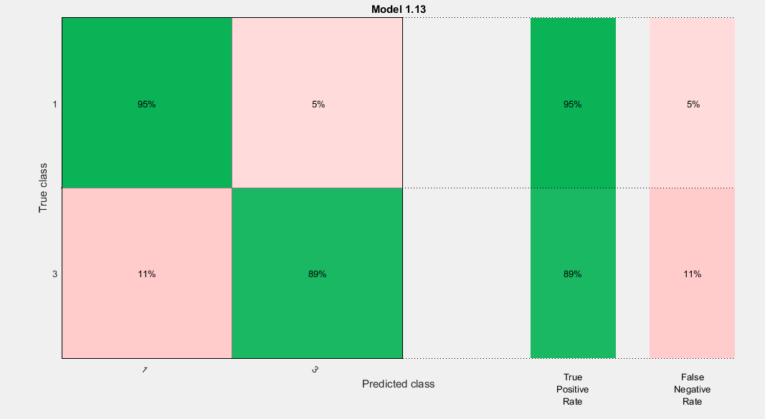

1. no variables excluded; no PCA; classes 1&2 and 3&4 lumped

Best classifier: KNN (k=1)

Accuracy = **93.5%**

AUC = 0.93

1. no variables excluded; no PCA; classes 1&2 and 3&4 lumped

Best classifier: KNN (k=1)

Accuracy = **90.9%**

AUC = 0.90

1. no variables excluded; no PCA; classes 1&2 and 3&4 lumped

Best classifier: KNN (k=1)

Accuracy = **88.3%**

AUC = 0.88

1. no variables excluded; no PCA; classes 1&2 and 3&4 lumped

Best classifier: KNN (k=1)

Accuracy = **92.2%**

AUC = 0.92

**Average accuracy = 91.42%**

GLRLMS { mean of all angles } (11/11) + GLCM { non-NaN matrix } (20/20) + Hu (7/7)

1. no variables excluded; no PCA; classes 1&2 and 3&4 lumped

Best classifier: KNN (k=1)

Accuracy = **88.3%**

AUC = 0.88

1. no variables excluded; no PCA; classes 1&2 and 3&4 lumped

Best classifier: KNN (k=1)

Accuracy = **89.6%**

AUC = 0.90

1. no variables excluded; no PCA; classes 1&2 and 3&4 lumped

Best classifier: KNN (k=1)

Accuracy = **85.7%**

AUC = 0.86